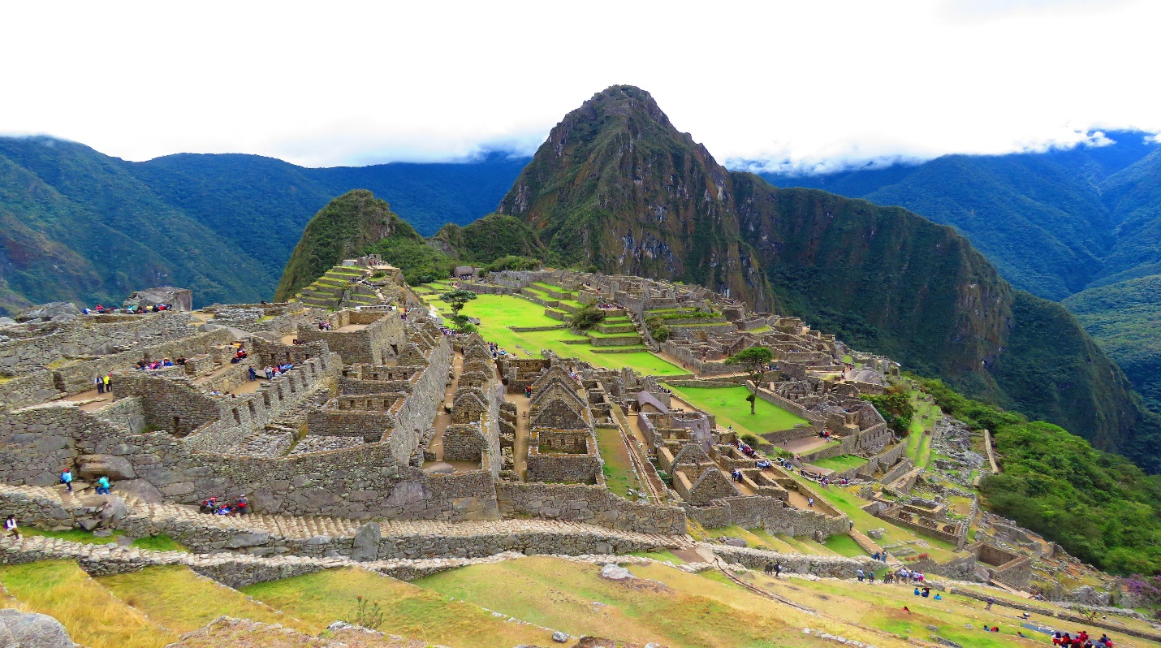

**Machu Pichu**

Machu Picchu is an ancient Incan citadel perched high in the Andes Mountains, renowned for its breathtaking architecture and panoramic views.

**History**

Machu Picchu, an ancient Incan citadel in Peru, was built in the 15th century and later abandoned, only to be rediscovered in 1911 by Hiram Bingham.